Geo-linguistic Mapping & Ethical Issues in

Endangered Language Research

Udaya Narayana Singh

1. Why Geo-linguistic Mapping?

Geolinguistics or linguistic geography as a field of study emerged in the late nineteenth and early twentieth century under the auspices of diachronic school of linguistics. It refers to theories and practices shared at the crossroads of geography and the science of language. Geolinguistics seeks to establish not only a search for and describe the relationship between speech production and geographic locations, but also a way to talk about perceptions of speech seen through the perspective of maps (colfa.utsa.edu/nwav39/workshops/geolx.pdf). To put it in a different word, it is an interdisciplinary field (Van der Merwe, 1992) which studies the spatial distribution of languages “with reference to their political, economic and cultural status” (Crystal, 2008:210). In linguistics the term is employed to indicate an approach that combines the outcomes of dialect geography, urban dialectology and human geography in a “sociolinguistically informed dialectology” (Crystal, 2008:210). Exploiting the notion of linguistic variables, propounded by William Labov, geolinguistics particularly tries to examine the spread of innovations in a geographical area and geographical distribution of linguistic features. In geography the term is deployed to indicate a developing branch of study that delineates the increasing concern of its parent discipline with various social problems. It also aims to devise appropriate methodologies for the analysis of “time-honoured questions of social investigation” (Williams, 1988: 2). The relationship between languages and their physical and human contexts is the main concern of it, says Williams (Williams, 1988: 2). Geolinguistics seeks
to illustrate the socio-spatial context of language use and language choice;
to measure language distribution and variety;
to identify the demographic characteristics of language groups;
to "assess the relative practical importance, usefulness and availability" of different languages from the economic, psychological, political and cultural standpoints of specific speech milieux;
to understand variations in their basic grammatical/ phonological and lexical structures, and
to measure and map "their genetic, historical and geographical affiliations and relations".
Peter Trudgill (Trudgill, 1983) holds that linguistic geography is dominated by linguists rather than geographers. Charles W. J. Withers, a professor of historical geography at the University of Edinburgh, says that the geolinguistic enterprise results primarily from a focus on “elements of language, and only then with their geographical or social variation, as opposed to investigation of the processes making for change in the extent of language areas.” (Withers, 1993)

20th century saw a fundamental shift of ideas that took place in the study of human geography which was dominated by physical influences (Pryce, 1982). Portraying the cultural perspectives, treating human aspirations and artefacts as a contingent but integral part of the environment became the objects of interest to geographers. Carl Ortwin Sauer (1889-1975), the American Geographer famed as the father of cultural geography, was instrumental in incorporating the effects environmental influence in the study of human geography in addition to physical aspects (Sauer, 1925). The works of European cultural geographers like Vidal de la Blache, H.J. Fleure, Jules Gillieron, Edmond Edmont, Estyn Evans and E.G. Bowen constitute the earliest literature that marks the beginning of modern–day geolinguistic enquiry. Lukerman (1965) suggested that "the genre de vie or the culture of a population or place is explicitly an historical accumulation of habit. Human inventiveness and freedom are, above all, a social fact, not an individual exploit ...The essence of French writing on genre de vie is an express emphasis on the historical background of social behaviour and on the force of social habit as the mechanisms of relationship with the physical environment."

The inspiration of geolinguistic enquiry was preceded by works of dialectologists and the compilers of linguistic atlases. In the dialectal studies of yesteryears a particular locality used to be selected to collect data from local speakers with emphasis on sounds, grammar and the syntax, not sticking to vocabulary. The collected materials were compared with those of other dialects by consulting the glossaries and could be explained with the aid of traditional grammars. Countries like Germany and France initially conducted geolinguistic researches (Iordan, 1962), which was then taken up by Italy, Switzerland, Spain and also other continents (Cardoso, 2010). Though dialectology did not become a field of formal study until the mid 19th Century, the knowledge of dialect differences goes back to antiquity. The issue of dialect differences got due attention in the grammatical treatise of Greek and Sanskrit. In the latter half of the 19th Century Ellis’s (Ellis, 1889) extensive survey of the contemporary English dialects can be treated as the first major contribution to the study of dialects. Similarly Winteler’s study (Winteler, 1876) of the Kerenzen dialect of Switzerland was the first major dialect survey outside the English world. Mention may be made of George Wenker’s Deutscher Sprachatlas, the most ambitious dialect survey project that was inspired by the Neogrammarian hypothesis of sound change in Germany (Wenker, 1876-1956). In 1896 the Swiss dialectologist Jules Gilliéron and Edmond Edmont spearheaded another trailblazing linguistic survey—the Atlas linguistique de la France (Gilliéron and Edmont 1902-1913). In the Americas, it reflected in the work by Hans Kurath in preparation of the Linguistic Atlas of New England (LANE), Tomás Navarro with the study of Puerto Rican Spanish and later by other scholars in Colombia, Mexico, Chile and Brazil. Kurath’s work needs special mention here as it can be treated as a precursor of modern geolinguistic study proper. In 1929 the Linguistic Society of America, the Modern Language Association and the American Council of Learned Societies commissioned a team of linguists to plan a survey of spoken language of United States and Canada. In 1930 it was decided that an “experimental survey” (Kurath, 1934) should be undertaken of New England area. The survey was conducted from 1931 to 1933—416 speakers were interviewed in 213 communities in the New England states. “The responses to the 750 item questionnaire were recorded in phonetic transcription without the benefit of electronic recording.” (http://www.lap.uga.edu/Site/LANE.html). Kurath’s survey paved the way for many more surveys in the field of areal linguistics producing extensive cartographic work, viz. Linguistic Atlas of the Middle and South Atlantic States (McDavid and O’Cain, 1980), Linguistic Atlas of the Gulf States (Pederson et al., 1986), The Atlas of North American English (Labov, Ash, and Boberg, 2006), The Modern Language Association Language Map: A Map of Languages in the United States (2009), etc. Today there are several societies and institutions which promote and foster geolinguistic research, e.g. The American Society for Geolinguistics (founded in 1965 by Mario A. Pei, a noted linguist and polyglot, who “introduced a tri-partite division into descriptive linguistics dealing with the synchronic analysis, and geolinguistics dealing with the relation of language to its speakers as they are spread over the world”— www.geolinguistics.org), The International Society for Dialectology and Geolinguistics (founded in 1990s— http://www.geo-linguistics.org/index.html), Foundation for Endangered Languages (promotes geolinguistic research on endangered languages— http://www.ogmios.org/index.php), Linguistic Atlas Project (http://www.lap.uga.edu/), Ethnologue (founded in 1951— http://www.ethnologue.com/), etc.

Nowadays mathematical algorithms, which was developed by the Romance dialectologist Goebl (1982, 1984, 2005, 2006, 2007) following the work of Séguy (1973), are being employed in the area of map-based dialectology to generate maps out of cumulative geolinguistic data sets, known as dialectometry. In contradistinction to traditional dialect geography, which is restricted to the mapping of isolated dialect features or combinations of features in a selective or intuitive way to define dialect areas, dialectometry makes visible geographical patterns to discover high-ranking spatial structures using as many linguistic variables as possible. Goebl and his followers (Kelle 1988, Hummel 1993, Schiltz 1996; Rumpf et al. 2009; Pickl & Rumpf 2011) have used existing dialect maps representing single variables for their purposes. Another school of dialectometrists led by Nerbonne (Nerbonne 2006, 2009; Heeringa 2004; Heeringa & Nerbonne 2001; Nerbonne & Siedle 2005) makes extensive use of elicited data sets like questionnaire data or translation task data. Techniques of Levenshtein distances (propounded by Russian mathematician Vladimir Levenshtein in 1965) or edit distanc are employed to measure distance between items or sets of items (vide Heeringa 2004 on Levenshtein algorithms) (Auer, 2013).

Geographic information system (GIS) is a digital system for capturing, storing, checking, and displaying data related to positions on Earth’s surface. GIS is capable of showing a plethora of different kinds of data on one map. This system equips us to see, analyze, and understand patterns and relationships more easily and effectively. With the help of GIS technology it is easy to compare and relate different parameters at various locations. E.g., using GIS the same map could show sites that produce pollution (such as gas stations, industries, vehicles, etc) and sites that are sensitive to pollution (such as wetlands, natural livestock, etc) (http://nationalgeographic.org/encyclopedia/geographic-information-system-gis/).

In recent years geolinguistic enquiry employs techniques of Geographic Information System (GIS) to construct language atlases, including recent online atlases (Lee & Kretzschmar, 1993; Luo et al., 2000; Wang et al., 2006). The Geographic Information System (GIS) emerged as a powerful tool in the 1960s to analyse, manage and display spatially referenced information. GIS uses maps which portray authentic and logical compilation of topographic information. Geographic mapping of linguistic data involves the following tasks
High quality and manifold visualization techniques
Work with large numbers of data (aggregate data, quantitative mapping)
Geocoding (includes different types of linguistic/extra-linguistic data, comparison of data)
Work with datasets that contain attributes (linguistic, social, etc.)
Perform spatial and geostatistic analyses (interpolation, clustering, etc)

The characteristics of geographical space and the way people inhabit it are two factors that are found to be important in studying language variation and change. The task of Mapping and measuring linguistic diversity in a geographical area like India becomes crucial in capturing the linguistic repertoire of this country. Geolinguistic mapping is the most powerful technique to show the distribution of languages through space and the regional linguistic variations within languages. In India, Anthropological Survey of India launched the “People of India”project in 1985 to generate an anthropological profile of all communities within its borders—the findings of which are published in People of India series (Singh, 1993). Prior to that H. S Gill’s (1973) Linguistic Atlas of the Punjab shows the first ever initiative to study the linguistic scenario of any Indian state on geolinguistic principle. In 2004 the Controller of Publications, Govt. of India published the first language distribution map of the country based “on the language data of Census 1991” (Singh & Banthia, 2004: viii) with 68 maps showing the distribution of 114 languages. Language Atlas of South Asia (Osada and Onishi, 2012) is the latest addition to the spatial-linguistic study of India, nay the entire South Asia. But till date no such comprehensive geolinguistic study of minority or endangered languages is available.

2. The Tasks at Hand

The primary need for field surveying is to choose the area and languages which need to be surveyed. To fulfil this task following methods could be applied:

Follow Census Report (2001), Language Atlas by UNESCO (2010), or Ethnologue (2015) to find out the areas where most of the endangered language speakers are surviving.

Find out the areas where the numbers of tribal people are more.

Locate the border areas where due to socio-political reasons migrated people are more in number and the community loses its original language. Thus the community becomes multi-lingual and people start following the dominant language/s.

Another linguistic character of the border areas and the big cities is that the migrated people (particularly the young generation) leave their native language and co-adapt the dominant language of that place. These areas should be included for endangered language survey.

According to recent Census report the gradability of endangerment of language becomes more where the younger generation doesn’t use their native language anymore due to socio-politico-economic reasons. Following Census report those areas need to be defined and surveyed.

In what follows, a set of four language family maps are presented to give an overall picture. It may be noted that in the 10,000 plus list released by Census of India, where 122 languages figure, the distribution of these is reflected in these maps. They will look obviously different if one trusts the Ethnologue or the Peoples’ Linguistic Survey of India (PLSI), or the People of India data prepared by the ASI is taken as source material. For example, under the encyclopaedic People of India (henceforth, POI) series of reports, the Anthropological Survey of India had identified 75 "major languages" out of a total of 325 languages used in Indian households. Ethnologue, too reports India as a home for 398 languages, including 387 living and 11 extinct languages.

3. Major Language Families of India

Languages spoken in the South Asian region belong to at least four major language families: Indo-Aryan (a sub-branch of Indo-European family), including Dardic sub-family of languages Dravidian, Austro-Asiatic, and Sino-Tibetan. Almost one third of our mother-tongues (574 languages) belonged to the Indo-Aryan family of languages - spoken by 73.30 per cent of Indians. The Dravidian languages, 153 in number, form the second major linguistic group of the country (24.47 per cent). Less than one per cent, 0.73 per cent, of the total population of the country with 226 languages are spoken under the Tibeto-Burman sub-family (belonging to to the Sino-Tibetan or Tibeto-Chinese family), including the lone language Khampti. The 65 languages belonging to the Austro-Asiatic family of languages accounted for a total number of 6.19 million speakers. In addition to these, 530 mother-tongues are recorded as unclassified languages. In fact, South Asia has been recognized in the serious literature on historical linguistics as one entity, not only because of the movement and admixture of ethnic groups, but also because of the discovery of surprising similarities of structure and function that the South Asian languages developed over several millennia that prompted scholars like Murrey B. Emeneau (1956) to come up with the concepts like ‘India as a linguistic area’.

As has been seen from the studies on genetic classification of languages in South Asia, there have been two types of claims of genetic relationship leading to setting up of language families. The first are based on lexical or sound correspondences among these languages, and the second type are those which make claims without going through historical-comparative methods of establishing cognates. As Voegelin and Voegelin (1973: 141) say, “A good example of the former is the renewed proposal for the Austro-asiatic phylum in which Munda may now be grouped with some confidence. Examples of the latter are claims without adequate support, as the claims that Dravidian, though unrelated to any other language family in South Asia, is still related to one or another language family in some major region more or less adjacent to South Asia. Despite the fact that such claims are unsupported or inadequately supported, it is not possible to disprove them; it is only possible to dismiss them”, as Krishnamurti (1969: 309-33) comments: "Attempts to trace genetic connections between Dravidian on the one hand and other languages such as Caucasian, Korean, Egyptian and Sumerian on the other may be passed over in silence, since the methods and materials used in their support have been unimpressive.”

Census of India (2001) records 22,774 speakers of Iranian Sub-family with two languages, Pashto and Persian, and 226,449 speakers of English (Germanic Sub-family under Indo-European) as mother-tongue, and 51,728 speakers of Arabic (Semito-Hamitic family) mother-tongue. It is also mentioned there that “The balance of 1,762,388 (0.17%) population out of total Indian population 1,028,610,328 comprises of 1,635,280 speakers of those languages and mother tongues which were not identifiable or returned by less than 10000 speakers at all India level and the population ( 127,108 persons) of Manipur which was not included in language data since the Census results were cancelled in 3 sub-divisions of Senapati district of Manipur.”

The endangered and now extinct languages of the Andaman Islands form a fifth family, which could be called the Great Andamanese language family, comprising two sub-families, namely, the Great Andamanese, comprising a number of extinct languages apart from one highly endangered language with a dwindling number of speakers, and the Ongan family of the southern Andaman Islands, with two extant languages, Önge and Jarawa, and one extinct tongue, Jangil – as suggested by Burenhult (2014). In addition, Sentinelese, an unattested language of the Andaman Islands, is generally considered to be related and part of this language family.

There are also mentions of a Tai-Kadai language family, under which would come small Tai communities and their languages spoken in Assam and Arunachal Pradesh together with Sino-Tibetans, e.g. Tai Phake, Tai Aiton and Tai Khamti language, which are similar to Shan language (in the Shan state of Myanmar), Dai in China’s Yunnan and Zhuang in Guangxi, Lao of Laos, and Thai. But this needs further investigation.

4. Maps of Language Families of India

In this sub-section, we present four maps belonging to four major language-families of India.

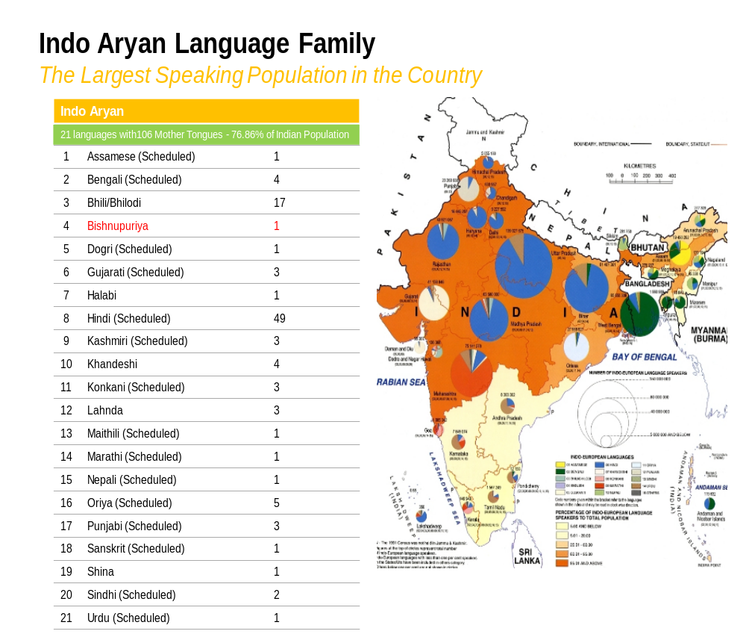

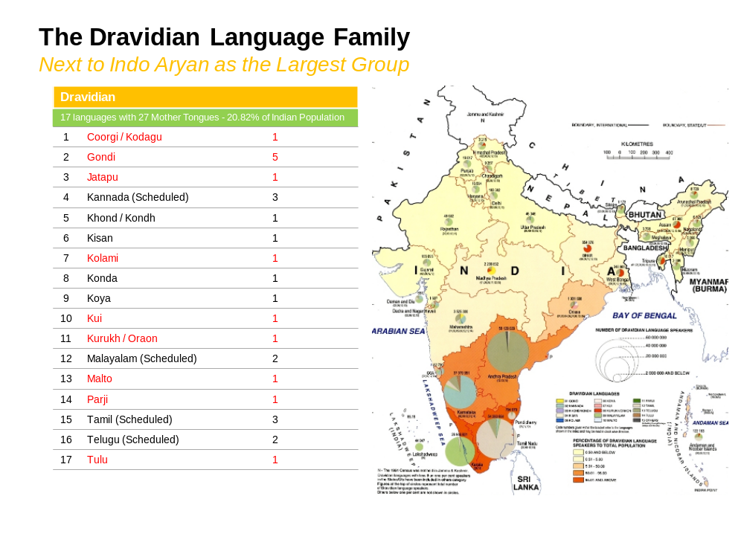

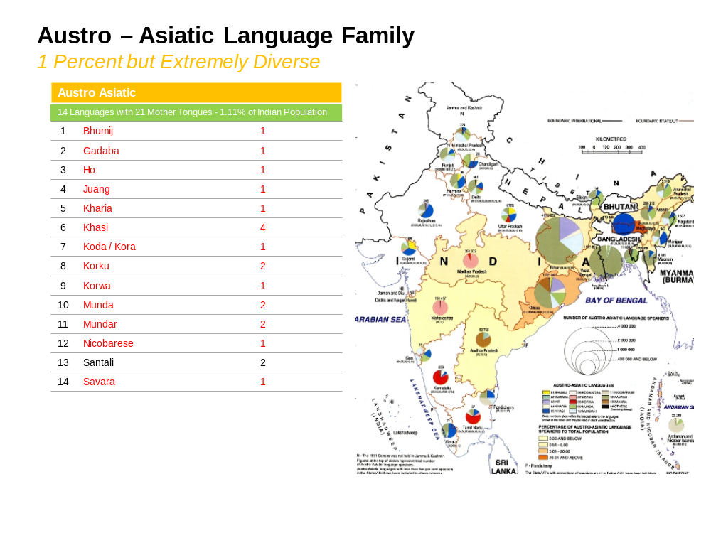

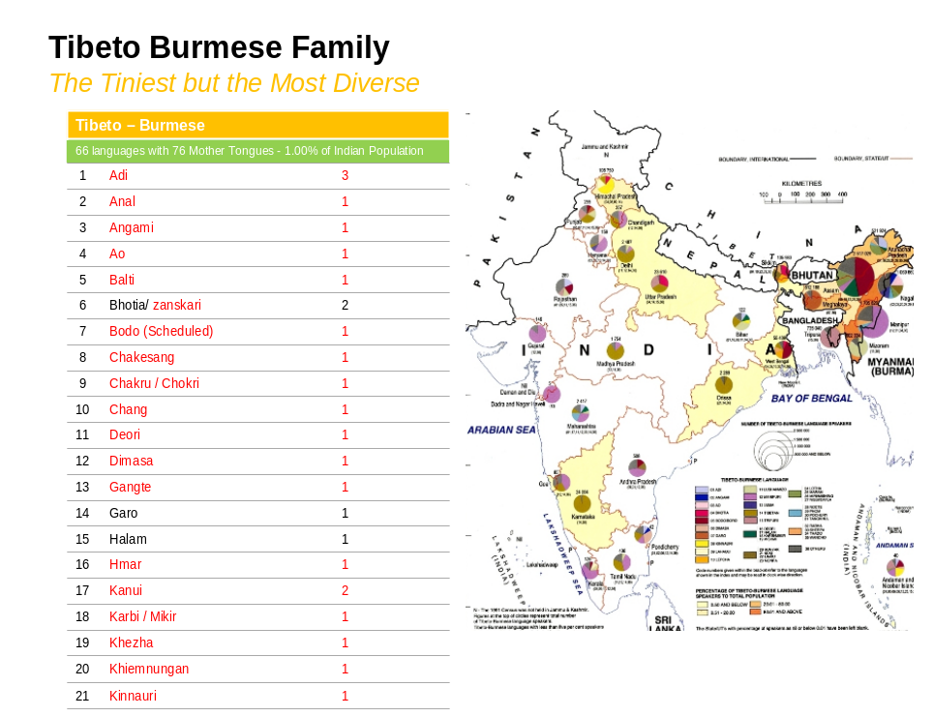

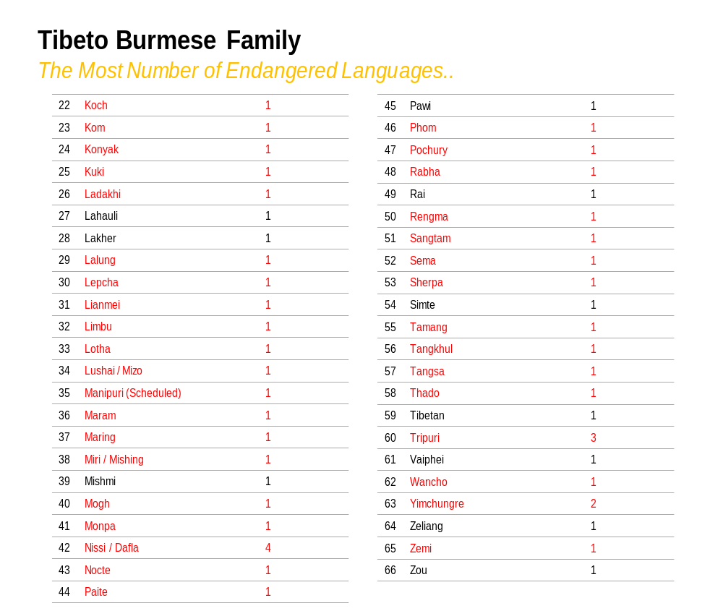
5. Why this Task is important

In Williams (1988) volume, we find a good coverage of the field of Geolinguistics, and its origins, principles, methods and applications. That it is very different from the purely descriptive compilations under the broad category of 'linguistic geography' is clear to the dialectologists. As many as seven out of ten chapters are case studies in the Celtic region with respect to majority-minority relationship. These are a great learning for those working on language endangerment. One only wished the volume could cover the areas under language-based conflict in Europe, say, Yugoslavia, Spain, the USSR or even Belgium. In fact, that demography could affect ethnic conflicts, and that it was an important factor for the long-term survival and evolution of languages could be seen in Belgium where after five generations (1830-1980) of higher fertility in Flanders, the trend changed for the sixth and probably reversed for the seventh generation, as population growth projection indicated, based on 1991 census. On the issue of ethnic purification – a trend that goes on from time to time, or perhaps all the time silently in many nation-states, there have been many strong comments, and one of those was by the then US President in 1917. In an address to the US Senate in January 22, 1917, President Woodrow Wilson had said: "Victory would mean peace forced upon the loser, a victor's term imposed upon the vanquished. It would be accepted in humiliation, under duress, at an intolerable sacrifice, and would leave a sting, a resentment, a bitter memory upon which terms of peace would rest, not permanently, but only as upon quicksand." It is this quicksand in Central Europe that escalated inter-lingual and inter-ethnic conflicts in later times. Whenever ethnic groups perceived as folks without any history woke up ina country, that led to problems of rise of sub-nationalities, which the central authorities in all nations thought must somehow be curbed. That attitude ultimately led Europe to another and a bloodier world war that left more than 20 million people affected directly. After the Council of Europe established its Court of Human Rights in the post-WWII period in 1949, the UN Commission on Human Rights made appearance in 1978, and that was when we find this definition proposed by Prof. F. Capotorti (1977-79) that entered into Art. 2 of the Draft Convention on the Protection of Minorities of the Council of Europe, open to Member States since 5 November 1992. Any geolinguistic map should be able to show the position of these minorities, who according to him are “a group numerically inferior to the rest of the population of a State in a non-dominant position, whose members being nationals of the State - possesses ethnic, religious or linguistic characteristics differing from those of the rest of the population and show, if only implicitly, a sense of solidarity directed towards preserving culture, traditions, religion or language" (as quoted in Kormoss 1993: 203).
In this context, it is perhaps important to quote the Arfé Resolution adopted by the European Parliament in 1981, calling on the Member States to accord certain basic rights to the linguistic communities of EUR 12 which could be classified in the following four groups:

1) The languages of two small independent States which are lesser used by any international criteria ie Irish and Letzebuergesch;
2) The languages of small nations or national groups, which have not got a State of their own, and which live in one or other EC Member State eg Welsh, Breton, West Frisian;
3) Languages of small nations or national groups who live in two or more EC Member States e.g. the Basques, who live in Spain and France and the Occitans and the Cata- lans which are found in Spain, France and Italy; and
4) Languages which are lesser used in a particular State but which are official majority languages in other countries e.g. German in Belgium and Danish in Germany.
Accordingly, "The European Bureau for Lesser Used Languages" or EBLUL was set up to protect and promote the lesser used autochthonous languages in a non-partisan manner with respect to race and religion. These, therefore, offer good models to the Indian state.

Useful Links
A. Resources
1. The American Society of Geolinguistics— www.geolinguistics.org
2. Endangered Languages Project, UNESCO— www.unesco.org/new/en/culture/themes/endangered-languages/
3. The International Society for Dialectology and Geolinguistics— http://www.geo-linguistics.org/index.html
4. International Phonetic Association— www.internationalphoneticassociation.org/
5. Endangered Language Archive— www.elar-archive.org
6. Vanishing Voices of the Great Andamanese— www.andamanese.net
7. Central Institute of Indian Languages (CIIL)— www.ciil.org
8. Endangered Language Project, CIIL— http://www.thehindu.com/news/national/karnataka/ciil-to-document-500-endangered-languages/article5723168.ece
9. Foundation for Endangered Languages— http://www.ogmios.org/index.php
10. Endangered Languages Documentation Programme— http://www.eldp.net/
11. Endangered Languages Archive— http://www.elar-archive.org/index.php
12. Ethnologue— https://www.ethnologue.com/
13. International Mother Language Institute (IMLI)— http://imli.gov.bd/
14. Summer Institute of Linguistics (SIL)— http://www.sil.org/
15. University of California, Los Angeles (UCLA) Phonetics Lab Archive— http://archive.phonetics.ucla.edu/
16. The Endangered Languages Project— http://www.endangeredlanguages.com/
17. Linguistic Atlas Project— http://www.lap.uga.edu/Site/LANE.html
B. Tools for Typing and Data Input
18. Technology Development for Indian Languages (TDIL)— http://tdil.mit.gov.in (free UNICODE compliant typing tool for 22 Indian Languages are available here)
19. Society for Natural Language Technology Research (SNLTR)— http://nltr.org/ (for Bangla, Santali UNICODE compliant keyboards and fonts)
20. Microsoft Indic Language Input Tool— http://bhashaindia.com/Pages/home.aspx
21. IPA UNICODE Keyboards (for IPA transcription)— http://scripts.sil.org/cms/scripts/page.php?site_id=nrsi&id=uniipakeyboard
22. Keyman Keyboards— http://keyman.com/

Ethical Issues

Whenever a survey-based research is undertaken in Social Sciences and Humanities, because of the nature of the subjects involved and the stake of various segments of the survey, it would be essential to discuss debate and decide on the ethical issues as one begins. In fact, each survey should begin with an ethical statement. When we design a survey, the aims and objectives are usually matched with the scientific value of the work. That would include the cost estimates of the study, the possible gains from the results, the extent of welfare that might accrue to the community with which we are to work, the changes or plans of action we are suggesting to the powers that be, and the resultant ecosystem of speech groups living together in a space are all that need to be considered.
Because not many schools offer a course in field linguistics, the field methods mostly remain a subject to summer workshop programme only. Thus the methodology and ethical statement of field survey are not very clear to most of the researcher and surveyor. Researchers mostly keep themselves more engaged with the technical aspects of conducting research, or on how to meet the deadlines at any cost, and tend to ignore the ethical aspects of the entire activity. Granted that a good piece of research requires to be technically sound, but they need to be ethically grounded as well.
Cameron et al. (1992) has proposed three models on how to do the language survey in an ethical way. These three models are summarized below.

a. Ethical research: ‘In ethical research.... there is a wholly proper concern to minimize damage and offset inconvenience to the researched and to acknowledge their contributions....But the underlying model is one of ‘research on’ social subjects. Human subjects deserve special ethical contributions, but they no more set the researcher’s agenda than the bottle of sulphuric acid sets the chemist’s agenda.’’(Cameron et al. 1992: 14-15)
b. Advocacy research: ‘... the ‘advocacy position’ is characterized by a commitment on the part of the researcher not just to do research on subjects but research on and for subjects. Such a commitment formalizes what is actually a rather common development in field situations, where a researcher is asked to use her skills or her authority as an ‘expert’ to defend subjects’ interests, getting involved in their campaigns for healthcare or education, cultural autonomy or political and land rights, and speaking on their behalf ’’ (Cameron et al. 1992: 15). Sutton and Walsh (1979) note that ‘the field linguist has a responsibility that goes beyond working on the language the fieldworker must also work for the speakers of the language’ which clearly supports the advocacy model as defined by Cameron et al. In Sutton and Walsh’s discussion, the point of advocacy for the speech-community comes in several ways: the language belongs to the community, the linguist should prepare a report that can be appreciated by the community and the linguist should be prepared to work with bilingual education programs. Other linguists have been out-spoken proponents of advocacy research. Labov (1982) also addressed ethical considerations in language awareness program and followed the line of advocacy research.
c. Empowering research: “We understand empowering research as research on, for and with. One of the things we take that additional with to imply is the use of interactive or dialogic research methods, as opposed to the distancing or objectifying strategies positivists are constrained to use. It is the centrality of interaction ‘with’ the researched that enables research to be empowering in our sense; though we understand this as a necessary rather than a sufficient condition ... we [propose three] programmatic statement[s] and then pose various questions:
Persons are not objects and should not be treated as objects.
Subjects have their own agendas and research should try to address them.
If knowledge is worth having, it is worth sharing.” (pp. 22-24)

Craig (1993: 39-40) offers a preliminary list of ethical issues for the field linguist research. She addresses both issues that arise in the academic setting and those that arise in the field. According to her the field survey related ethics issues are as following:
1. Choice of consultants 2. Informed consent, a very key issue in social sciences about which linguists are mum. 3. Disclosure of purpose of the study. 4. Disclosure of source of funding 5. Relations to indigenous community 6. Relations to individual consultants 7. Relation to local scholars 8. Relations to local indigenous institutions 9. Relations to governments (work permits etc. ...).

All field linguistics activities in the area of Endangered Languages and Culture are mainly devoted to collect societal, demographic, cultural and ethnographical data along with language use and attitude details, while also covering the phonological and lexical information as side information, it is to be differentiated from the typical studio-like data collection environment used by the scholars in descriptive linguistics. As is obvious, any field work-based study mainly consists of two groups of people: fieldworkers and informants. Therefore, “a well-conducted interview is of value to a folklorist, an ethnographer, a lexicographer, a dialectologist, a phonologist, and an historian, not to mention the potential values to sociologists and experimental psychologists” (Clark 1971).
In the modern era of technology sharing data is much easier and researcher can conduct their research without gathering data from the subject directly. In these cases the subject is not being informed for which purpose his/her data are being used. According to the research ethics each and every informant should be informed about the future use of the data he/she provides. Their approval/permission—either audio-visually or in black and white—should be kept on record for publishing the data. It is a different matter that scholars in different disciplines can share a taped-interview where sharing the original tape opens the opportunity to different researcher to utilize those field data for their further research purpose, or for a greater detailed analysis. A great number of excellent research studies have been done in different corner of the world using the records of Linguistic Atlas. If it was not available most of the studies would not have been possible because of the practical difficulties, if not impossibility of conducting field surveys due to limitations of scholars and institutes. Such technological aids also help others to do the phonetic and phonological translation in a more acurate way where the fieldworker’s possible errors due to the audibility problem could be minimised, if not avoided altogether. But on the other side we till now need to be more dependent on the fieldworkers notes to find out the supra-segmental phonetic features of a speech sound. Responsibility of errors in data transcription should be borne by the transcribers.
In this context, one is reminded of the sarcastic comments that David Smith (1987: 56) had made about the “Cookbook” approaches in anthropology, linguistics and educational data gathering research manuals, although he agreed that there were “discovery principles that were meant to guide the development of the relationship between the fieldworker and the people [s]/he is working with in the field and that serve as constant checks on the progress of the research” (Smith 2002:174-175). As has been described by Perry Gilmore and Ray McDermott (2006), seasoned field workers such as Smith had always followed a set of Ten Principles in conducting field work, which are as follows:
Start with no preconceived notions about what's happening and what this means to participants: It is, of course, easier said than done, but for many of us as researchers, it is difficult to shed the baggage of our preconceptions, but at least we should try to postpone using them for judgement of persons or situations. David Smith found this out during his own research on the grammatical and semiological structure of the Kapsiki verb system, for which he was not sure if he must not use the stratification models of Lamb (1964) and Gleason (1964). He often warned that once you named something you stopped questioning the local epistemology, and therefore one should continuously interrogate to discover the situated meanings and consequences of the words collected, because related to these words are the speech community’s values, attitudes, and judgments.
Let the important questions to be addressed, as well as the answers, emerge from the context: The ideal strategy would be to allow the subjects or informants to narrate their own anecdotes, and interpretations, howsoever unprofessional or unscientific they may seem to the researcher, because from these stories would emerge many which one would not usually think about in the beginning. The surprises in the field work are as important as a dogmatic adherence to a fixed set of questions, as each endangered community may have a different set of stories to tell about themselves, their language and culture. While a lot of emphasis is laid on creating or producing rigorous data but in the end such fixed approaches might give us trivial or routine explanations. That David Smith thought would be a pity.
Do not view participants as subjects but as co-learners with the investigator, each using the other to reach shared and ever-deepening understandings: It may be important to take one’s informants seriously and respect their knowledge. Only then the researchers may hit upon deeper insights and better explanations.
Take seriously the uniqueness of each setting and set of events. Each field setting may have something to offer to the researchers, and like one should shed preconceived notions, one should also not begin with one’s own research ideology. The uniqueness of each setting deserves respect and reminds us of the need to deal with it through an in-depth analysis. Although the Chomskyan-Greenbergian tradition teaches us to search for generalizable knowledge from language data, as more and more time goes by, the particulars and the unique characteristics of each language, and its context occupies an important place in linguistic research. Of course, language universals, including language family traits as well as dissemination of a set of features over time and space are all very important but not at the cost of the data gathered. Earlier, many have found to be tweaking or fudging the data or parts of it to suit certain notions or generalizations but that is something to be avoided now.
Take as primary importance relationships rather than relata: Even as one sings the victory of the data in 4 above, this is also important to remember that our interpretations in the analysis of language and culture try and discover the ways things are related to each other, rather than the things we gathered and transcribed and heaped on one over another anyway. In fact, following David Smith’s example, we could see that many are "able to surface a reality whose presence and consequences are not easily accessible to other researchers" (Smith 1993:193), and that is what an anthropological or linguistic analysis is evaluated as a useful study. Language being a complex reality, it could only be explained in terms of ‘Relations,” both Grammatical and Social. Looking at a heterogeneous entity in a homogeneous manner or simply and unilaterally is not ethical.
Assume that people inevitably act to make sense of the world they are experiencing: This looks like a very basic thing to assume in Culture Studies but still needs to remember. Meaning of a sign or a symbol or an expression is defined or decided by the social aggregates because “most people, under similar conditions, with similar beliefs, and supported by similar regimes of pleasure and restraint, would generally act the same way” (Gilmore and McDermott, 2006: 205). Any different and deviant behavioural trait has to be investigated in terms of its complexity. How a speech community captures the universe they are inhabiting in their language structure is what one needs to discover.
Assume that patterned behaviour reflects the presence of underlying power relations: The researchers may do well to remember that at times the details and the particular traits may elude explanations, but one has to believe that social and cultural behaviours do have a pattern, and are – like many other social phenomena – governed by a set of power relations. Therefore, it may be important to make suggestions to an endangered community only after one finds out what these relationships are like – among their sub-groups as well as with others.
Recognize that genuine understanding can only come through genuine participant-observation: Any Participant-Analysis Research (PAR) would depend on the establishment of authentic status of a group, and on what its relationships are with others. If a researcher is unable to immerse oneself in participating or observing while conducting field work, many points may be missed out. These are never done in a hurry and there are no short-cuts. Gilmore and McDermott (2006: 205) comment on David Smith’s case studies by saying: “In a hilarious unpublished paper about his participant-observer stint with the Tes Tej, a tribe he "discovered" in a Center City bar in Philadelphia, he defined participant-observation as "a technique for getting information without paying and eating without hoeing" (1977:6).”
Ultimately the power to solve their problems, or even to determine what they are, rests with the participants of an Endangered Community: No matter what plans are made and suggested by the researchers or by the activists, one must agree that finally it would be the participants who could solve or answer their problems. Solutions could be suggested by the outsiders but solutions cannot come from their action alone.
Change takes place when we hear another "story," and when it resonates with our own experience, we feel like taking lessons from it for our cases: David Smith argues here that the real life decisions are not always based on statistical generalizations, and we quite often depend on authentic individual stories which we come across, including conflicting narratives. In addition, the daily journals of the researchers and assistants are often relied upon to gain insights, or parallel stories. The Voice of our Informants are often played down and hidden from our interpretive texts – a situation that calls for change. In addition, there should be ample scope for self-criticism.
Finally, as David Smith had suggested in several places, it will not be enough to uncover local "Funds of Knowledge," but how that could change our repertoire of solutions would be interesting. A real challenge facing ethnography today is “not only to surface the narratives of oppression, resistance and resilience, but for the edification of the academic community it must develop approaches that put these narratives to use in addressing the oppressive equations” (Gilmore and McDermott (2006: 205).
In 1979, the ‘National commission for the protection of Human subjects of Biomedical and Behavioural research’ (USA) published the Belmont Report which mainly focused on three principles; ‘respect for persons’, ‘beneficence’and ‘justice’. Canadian researchers follow Tri-Council Policy Statement which was adopted in 1998. Two essential components of this statement were: ‘morally acceptable ends’and ‘morally acceptable means to those ends’. Four of the eight guidelines of this statement are quoted below:
Respect for human dignity. ......It aims to protect ‘the multiple and interdependent interests of the person’. (p.i,5)
Respect for free and informed consent.(p.i,5)
Respect for vulnerable persons. (p.i,5)
Minimizing harm; non-maleficence. (p.i.6)
In 1980 TESOL published their research ethics guideline named ‘Guidelines for Ethical Research in ESL’ which in TESOL Quarterly which addresses six areas of concern in Second Language Learning Research ethics. These six areas are: informed consent, deception, consequences, privacy, confidentiality and anonymity.
Therefore, there are a few practical things to do as the field work progresses. First, our informants need to be informed about the purpose of the interview along with an information that this interview was going to be taped. The interviewer needs to be as skilled to take the interview in a way where the informants won’t be much conscious about the existence of the tape recorder. Secondly, the tape recorder needs to be placed in a way where it would be accessible by the interviewer but out of sight of the informant so that he won’t pay attention to the tape recorder. Thirdly, low impedance, unidirectional microphone can help to record the voice of the informant with a better and clearer speech-sound. Fourthly, practising nonverbal gestures is another crucial point to ensure the informants to give more comfortable and natural response. Like, when the interviewer will not be able to identify something said by the informants intervening the informant with ‘excuse me’ or ‘hmm’ sound will make it more comfortable for the informant rather than saying ‘say the right word’. Fifthly, the interviewer’s body language and attentive attitude towards the informants make the informant more enthusiastic to provide information as suggested by Clerk (1971). Using the taboo forms or a more natural use of a word or sound by the informant gives a more natural and distributive set of data. Sixthly, professional organizations, Institutes, specialised councils produce their own code of ethics along with following some universal code of ethics. Some famous code of ethics followed by different Institutes are- Tri-Council Policy Statement for Canadian Researchers, Declaration of Helsinki for World Medical Organization etc. The Nuremberg Code formed the first code of modern research ethics which grew out of the Nazi war crime trials following WWII. Though the principals mentioned here are mostly directed towards the medical research ethics, the first principal as quoted below is very relevant to educational research ethics also:
“Voluntary consent of the human subject is absolutely essential. The subject must be in a position to make an enlightened decision. This includes such factors as legal capacity to give consent, free power of choice, complete information on the nature, duration, and the purpose of the experiment and an explanation of any risks.”
Seventhly, along with the ethics need to be followed during the procedure of gathering data through interview from the informant/s, some other code of ethics need to be maintained in field survey.
The Linguistic Society of America Executive Committee adopted a statement on human subjects in linguistic research in 1992, as below:
‘Studies of a human language often depend upon a continuing relation with speakers of the language. Such a relation comes to be defined as much by the speakers as by the linguist. Their patterns of life govern when work can be done. Their expectations, and those of their community, shape what is to become of the results of the work. Understanding of the nature of linguistic inquiry grows in the course of the relationship. Sometimes lifelong friendships are established. Such work must be conducted with respect for those who participate, with sensitivity as to their well-being, and with concern for consequences of publication or sharing of results. Certain considerations may make the study of a language different from much research in the sciences and social sciences. One asks many questions in discovering the features of the language, of a kind the collaborator learns to expect and even anticipate. They are seldom of a sort that can be disturbing or injurious. Moreover, fruitful work may depend upon the linguist learning and observing the norms of politeness and friendship expected by those with whom he or she is talking. Those who participate in such a work often do so with pride in their command of their language and may wish to be known for their contributions. Not to disclose their names would do them a disservice. Native Americans sometimes justly criticize earlier work with their language for not having adequately proclaimed the contributions of the Native Americans themselves. Fairness to speakers of a language is very much a matter of understanding their viewpoint, and what is appropriate in one situation may not be in another.’’ (Human Subjects in Linguistic Research, May 1992, Linguistic Society of America Executive Committee)²

Then there are some purely administrative but practical problems as well. For instance, for work in remote and politically sensitive areas—like Nagaland, Manipur, etc.—work permit has to be procured from the competent authorities. In some of these areas use of GPS may not be allowed—digital/visual recording would be the only option. To conduct survey in villages, block or accessing the information for the purpose of research prior permission needs to be taken from the respective authority.
One of the most important parts of field work survey is to build up a relation with the speech community with whom they work. Samarin (1967) concludes that “the informant is an important member of a linguistic field project” (p. 44). Kibrik (1977) pointed out that ‘One shouldn’t forget that a person always remains a person: he gets tired, has unconscious lapses of attention, is psychologically predisposed towards certain kinds of activity, acts emotionally, has social prejudices, etc., which often have an unforeseen influence on the results of field work. But all these difficulties do not mean that one should forgo trying to actively influence the informant’s speech behaviour; they merely warn the investigator and force him at all times to take specific conditions of his work into account, which requires special methods for eliciting information and for carefully checking it.” (p. 54)
Kibrik also said that “a good informant is very rarely encountered if we demand a whole complex of qualities from him” (p. 54). These qualities include ‘knowledge of the target language’, ‘knowledge of the mediator language’, ‘translating talent’, pronunciation, the associative mobility of thought, patience, honesty and a lack of the feeling of ‘linguistic prestige’, ‘strictness, experience’, ‘linguistic unsophistication’ (pp. 54-56).
The surveyor need to take prior appointment with the informant while required according to both party’s convenience and should maintain the appointment time so that the informant need not to wait for the surveyor. Obviously, the interviewer should be very careful about not hurting the informant’s socio-cultural or religious sentiments and showing proper respect to the informant.
The informants and other sources need to be properly acknowledged in the survey report, including the points derived from personal communications and discussions. Though prior permission from the informant should be taken about revealing his/her identity. If the informant is not willing to disclose his/her identity anonymity needs to be maintained or pseudonym should be used. But Williams (1996) said that sometimes the informants do not like to using pseudonym as ‘the pseudonyms prevented key participants from receiving recognition for their successes’.
Maintaining the ethical code sometimes gives rise to ethical dilemma as well to conduct the survey. The first draft of the survey report should be given to the informant for his/ her response. But sometimes the informant feels hurt or embarrassed or outraged towards the report while the researchers feel those points offending the informant are integral to their study. Williams (1996) thus raised a question if the informant’s suffering discomfort towards the report can make an ethical obligation to the researcher to publish it.
The researcher/surveyor need to show his/her proper gratitude towards the informant for his/her kind help. Samarin also examines issues of remuneration with respect to selection of speakers in great detail:
‘It might be thought that remuneration in the form of money, goods, or services would be a compelling reason for a person to make himself available as informant. Sometimes pay is the only means of getting informants, and when work is regular and intensive, the informant will usually expect it; but often the winning of an informant is achieved by ingenious ways of gaining his confidence or interest. ... In some places the promise of pay is enough to entice almost anyone to work as informant, but in others hardly any amount of remuneration would strengthen an individual to go against the will of the community. If the researcher had established friendly relations with the community, a person might even be embarrassed in receiving pay publicly. He might want to consider the service an act of friendship. The rate of pay depends most of all on the local conditions, and not at all on the resources of the investigator. ... Whenever possible it would be advisable to begin with a lower rate than what one intended on finally giving. There are two reasons for this procedure. First, it is easier to dismiss a poorly paid employee than a highly paid one. Second, the increase in salary can serve as an encouragement for good service. ... More important than the actual salary is the kind of relationship it establishes. ... One of the undesirable aspects of our money economy in fieldwork is that it allows us to think that the informant is obligated to us for the salary he receives. This puts us in the position of power from which we can make all kinds of demands. The rightness of our position may appear to us incontestable since the work-pay pattern is so easily taken for granted in our Western society. The informant would see little sense in our view if it were explained to him, and when he does not understand the reasons for the investigator’s demanding attitudes and words, he will be hurt, embarrassed, or angered. ... Financial remuneration may actually be impossible in some situations, not because the informants do not want the money or cannot use it, but because they prefer another way to seal the bargain. ... Tricking informants into rendering free service is an extremely dangerous undertaking; an investigator who practices duplicity usually deceives nobody but himself. ... A better motive for reciprocity in fieldwork is the respect the investigator maintains for himself and his endeavors, a commodity whose value greatly exceeds the price which must be paid for it’’ (pp. 25-27, abridged).
Based on the suggestion by Samarin, payment, avoiding deception, and attending to good criteria in choosing someone to work with are the major ethical issues faced by the field worker along with the other factors as discussed above to make the survey study successful.
The researcher/surveyor need to show his/her proper gratitude towards the informant for his/her kind help. The informant also needs to be paid honorarium for his/her valuable time which they have given to provide data and make the research successful.

Grierson (1903-23) puts it as parallel to Indo-Aryan under Indo-Iranian, and Georg Morgenstierne (1973) places Dardic and Nuristani of Afghanistan as two sub-families parallel to Indo-Aryan.
Retrieved on 8th April 2016 from: http://www.censusindia.gov.in/Census_Data_2001/Census_Data_Online/Language/statement9.aspx
Data taken from Ethical Dilemmas Facing Action Researchersby M.B. Trites and J. Belanger, 2005.

